**Hybrid Recommender System**

**Yaqi Zhou; Yanan Huo; Li Luo; Kejia Shi**

**March 2016**

**1. Abstract**

With the development of Internet, the new era of big data is approaching and personalized recommendation services has become a new fashion. We mainly use R to explore and develop the algorithm with package *Recommenderlab*, where the collaborative filtering algorithms have been developed maturely, to some extent. The two main parts in this report are exploring the R package to predict the ratings based on the 100 thousand MovieLense dataset and combine the information from both users and items to develop a new algorithm to solve the cold start problem. Furthermore, we also managed to connect to the Center for High Throughput Computing to realize the algorithm on the 20 million MovieLense dataset.

**2. Plan**

The first thing we did is to explore the 100 thousand MovieLense data set from website, comparing it with the built-in data set in the *Recommenderlab* package and to make sure that the codes in R can be generally utilized into both data sets. The data set from website with several files are not completely accurate or concise as the built-in data set, where there are some overlapped documented ratings for the same user and the same item and even some movies have two item ID numbers. To prevent the similar situation happened to the 20 million dataset, we developed our own R code to tidy up the data set. Meanwhile, data visualization is a necessary process to express the data structure in a macroscopicalrespective, which is shown in the next part.

Secondly, we looked through several papers about the recommender system to learn the algorithm inside the package and even a book by S.K. Gorakala and Michele Usuelli, 2015. Following these papers and book, we learned the mechanism of the recommendation models and evaluated the predict result. We have plotted out the ROC curves and compared them based on one-user prediction.

Moreover, we recognized some limitations of collaborative filtering algorithms, such as the data sparsity problem, especially the cold start challenge, which means that recommendations for new items or new users cannot be provided because no historic records are found. The algorithms we used in the Recommenderlab package only take the rating matrix into account; however, not only users’ ratings for items, but also users’ own features, such as users’ demographic characteristics and users’ preference for some properties of items, contribute to the similarities between users. Therefore, we intended to combine other information to improve our previous recommend system and fix the cold start problem.

Here we proposed a hybrid collaborative filtering algorithm based on users’ ratings and user’s features. Specifically, the users’ features could be further divided into users’ demographic characteristics, like age, gender and occupation, and user’s preferences for movie genres. If we would like to recommend for an old user, we calculated weighted sum of the similarities between this user and any other user based on user’s demographic characteristics, user’s preferences, as well as user’s ratings. Then 60 neighbors were selected and ratings for movies that had not been watched were forecasted. On the other hand, we created an information database of demographic characteristics and preferences for movie genres so that we could tell a new user’s movie genre preference given his or her demographic features. Hence, similarities between the new user and every old user could be computed and recommendations for new users are no longer impossible.

**3. Hybrid Collaborative Filtering Algorithm**

The flow chart for our hybrid collaborative filtering algorithm is given as follows:

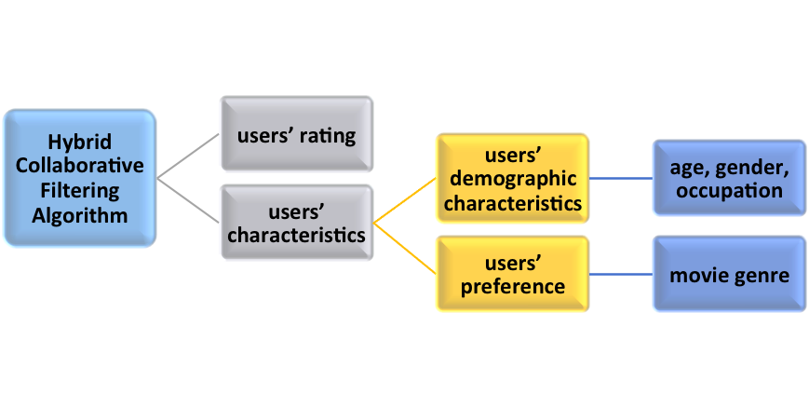

There exist two situations when we predict ratings of items for our target user.

1. Predictions for old users

If the target user has already rated some movies, then we can check what kinds of movies he or she rated more frequently and higher. Thus, we have information about his or her preference of movie genres. The overall similarity between two old users $a,b$ are calculated according to the following formula:

${sim}_{overall.old}(a,b)=α{sim}_{demo}(a,b)+β{sim}_{preference}(a,b)+(1-α-β){sim}_{rating}(a,b)$ (1)

, where ${sim}_{overall.old}(a,b), {sim}_{demo}(a,b), {sim}_{preference}(a,b)$ and ${sim}_{rating}(a,b)$ refer to the overall similarity, similarity based on users’ demographic characteristics, similarity based on users’ preference for movie genres and similarity based on ratings in the past between user $a$ and user $b$, respectively. It’s worth mentioning that similarity based on ratings in the past between user $a$ and user $b$ can be produced using the Recommenderlab package. Besides, $0<α, β<1$ and $α+β<1$. $α$, $β$ are weighting parameters whose values will be chosen according to mean absolute error (MAE) during the experiment. The mean absolute error is a quantity used to measure how close forecasts or predictions are to the eventual outcomes, which is defined as

${MAE}_{a} =\frac{1}{n}\sum_{h=1}^{n}{|S_{a,h}-y_{a,h}| }$ (2)

, where $S_{a,h}$ is the rating prediction of the $h^{th}$ item for user $a$, while $y_{a,h }$ is the corresponding true rating. And $n$ is the number of movies that user $a$ has rated. The less the MAE is, the more accurate the prediction is. We use MAE as our standard because it has the same scale as our rating value, which gives us more intuitive feeling about the deviations of predictions from the true values.

After calculating the overall similarities between our target user and any other user in the dataset, it is easy to pick nearest neighbors for the target user. In this study, we chose 60 neighbors. The rating prediction, $S_{a,h}$, of the $h^{th}$ movie for our target user $a$ is thus calculated as belows:

$S_{a,h}={\overline{P}}_{a} +\frac{\sum_{b∈kNB}{{sim}_{overall.old}(a,b)}(P_{b,h}-{\overline{P}}_{b})}{\sum_{b∈kNB}{{sim}_{overall.old}(a,b)}}$ (3)

, where ${\overline{P}}_{a}$ is the average rating for movies that user $a$ has rated; similarly, ${\overline{P}}_{b}$ is the average rating for movies that user $b$ has rated. And user $b$ belongs to the k nearest neighbors, kNB, of user $a$. Here, k=60.

Obviously, we brought in the average rating for user $a$ instead of using weighted average rating for user $a$’s k nearest neighbors. The reason for this is that different users have different rating habits and rating scales, which can be reflected in the ${\overline{P}}_{a}$.

1. Predictions for new users

For new users, we are lack of information about previous ratings. Therefore, only users’ demographic characteristics and users’ preferences for movie genres are available. What is more, new users’ preference for movie genres is forecasted based on his or her demographic features. In other words, we can divide old users into various groups according to some demographic feature and summarize the movie genre preferences for these groups into a lookup table; we can predict what types of movies new users are more likely to watch on the basis of those lookup tables. And then, the similarity between the new user $a$ and any old user $b$ are calculated as belows:

${sim}_{overall.new}(a,b)=|\frac{C_{a}\bigcap{C_{b}}}{C_{a}\bigcup{C_{b}}}|$ (4)

, where $C_{a}$ represents user $a$’s all characteristics, including demographic characteristics and preference for movie genres; $C_{b}$ represents user $b$’s all characteristics. $C_{a}\bigcap{C_{b}}$ refers to the characteristics in common for user $a$ and user $b$. While $C_{a}\bigcup{C_{b}}$ refers to the all characteristics that either user $a$ or user $b$ has.

The similarity measure above is called Jaccard coefficient, which measures similarity between two finite unordered sample sets. Without users’ ratings, it is reasonable to use Jaccard coefficient to calculate similarity in this scenario.

Because new users do not have previous rating records, they do not have average rating for movies that they have rated, ${\overline{P}}_{a}$. The rating prediction, $S_{a,h}$, of the $h^{th}$ movie for our target user $a$ is thus calculated using following formula:

$S_{a,h}=\frac{\sum_{b∈kNB}{{sim}_{overall.new}(a,b)}P_{b,h}}{\sum_{b∈kNB}{{sim}_{overall.new}(a,b)}}$ (5)

, where the notations have same meanings as they do in Formula (3) and (4).

**4. Result**

**4.1 Collaborative Filtering Algorithm Using Recommenderlab in R**

1) Data Exploring

In the beginning, we developed our own code to tidy up the 100 thousand data set and explore the nature of it. We have 943 users and 1664 movies the data set, with 99392 ratings. Firstly, similarity between users and between items is the main measurements that collaborative filtering algorithms based on, where it is calculated relied on the similarity of rating. To illustrate, we display the first hundred users and first hundred items to lay out the similarity within users and items.

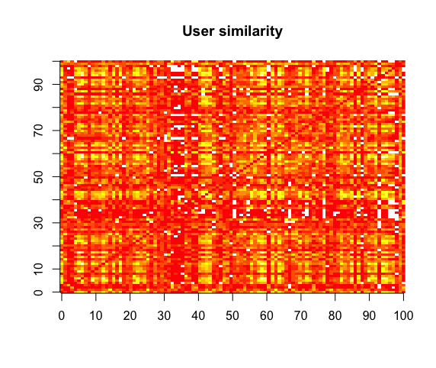

**Figure 1.1.1**The similarity among the first-100th users. The deeper the color, the more relevant the two users based on their ratings.

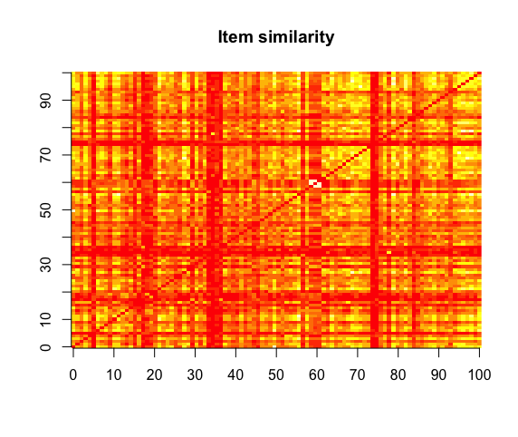

**Figure 1.1.2** The similarity among first-100th movies

In the two similarity figures, we can see that both of them are symmetric over the red diagonal line, which is obvious that the similarity between the *i*th user and the *j*th user is the same with that between the *j*th and the *i*th. As expected, there are blank areas in the similarity matrix, which means that there is no overlap on the movies that the two users rated or the two movies have entirely different ratings.

Since there are plenty of unrated items, the rating matrix must be a sparse matrix, with few rating values. We got rid of the large amount of missing values and picked the 99392 ratings out to explore the details. We drew a histogram of the ratings without missing data and it tells that most ratings are larger than 2 and 4 is the most common rating.

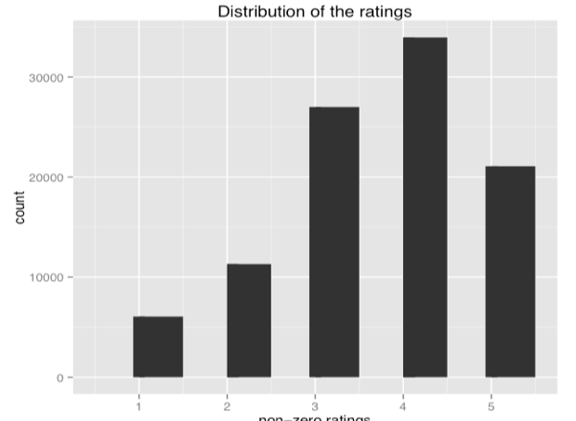

**Figure 1.1.3** Histogram of the ratings without missing values

Merely knowing the rough distribution of ratings are far from knowing well the nature of this data set. From the *Recommenderlab* package, we can learn quickly the number of non-missing values for each column and also the average value within columns. Then, we can sort the Movies by the number of rated, which can be interpreted as the popularity ranking, to some extent. The next plot shows that the number of views of the top-ten movies.

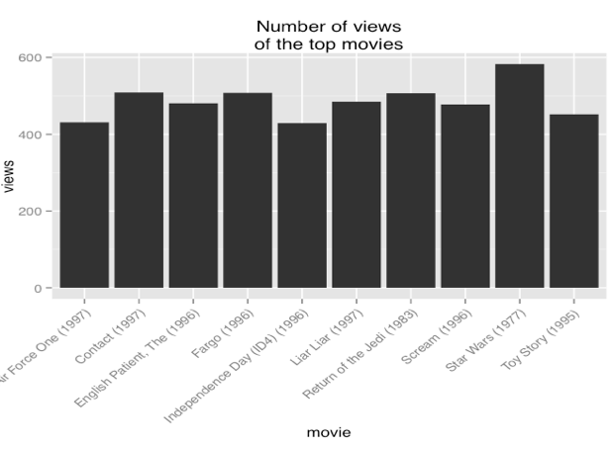

**Figure 1.1.4** Number of views of the top-ten movies

Since that different users have their own judgment criteria, there may be bias within a user and sequentially, removing this effect by normalizing the data is the next step. To normalize the data, we expect the average of each user is 0. To see whether there is bias existing within a user, we plot out the heatmap before and after normalization to indicate the necessity of normalization. Of the following plot, we use the “z-score” method to normalize with subtracting the average and then divided by the standard deviation. The other method, “centering”, only subtracting the average.

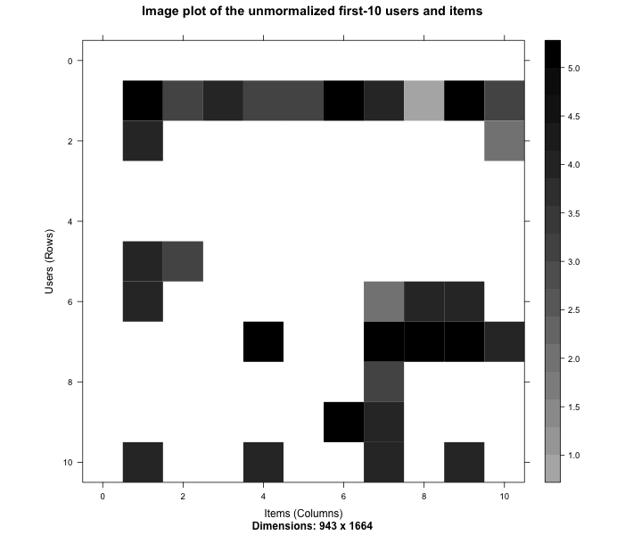

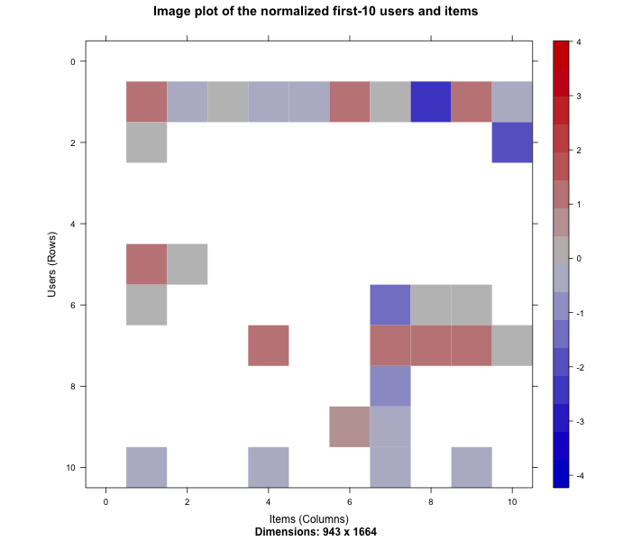

**Figure 1.1.5** The heatmap of the first 10 users over the first 10 items before and after normalization.

Comparing the two figures above, the 10th user (row) could be the most typical user to explain the importance of normalization, where he gave all the 4.0 rating of the first four items, while after normalization, the 4.0 rating turns out to be -1.0, which is even below his average rating. The similar situation happens through the whole data set, thus we must normalize the data before applying models on it.

The data set from website also contains the information of demographic characteristics such as gender, age and occupation. To explore the effectiveness of demographic characteristics on ratings, we drew out several histograms to reveal their distribution.

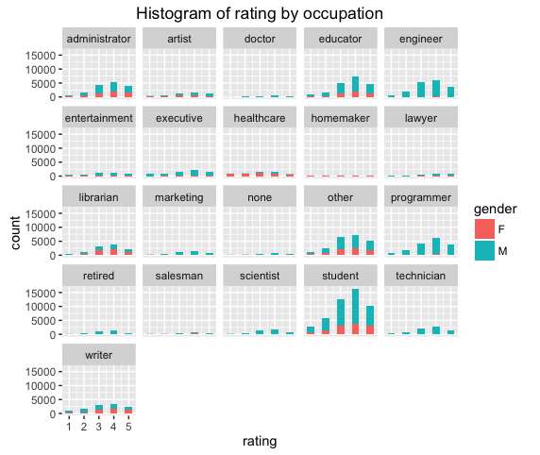

**Figure 1.1.6**

The figure above indicates the circumstance in the data set that male and female do relate to the type of occupation. For example, most of people doing jobs relevant to healthcare and homemaker are female and most of programmers and male. In general, male rate more than female, while both of male and female fate mostly rate 4 and 1 least. Moreover, we can see that the differences of the amounts of each rating do vary for each occupation. Thus, we may have reason to believe that only utilizing rating matrix losses information about the feature of users.

Also, we plot out other figures about other demographic characteristics over rating to explore the relationship between them, but we are not going to display them here, since figure 1.1.6 is a typical one.

2) Data preparation

To prepare the data, we follow the next two steps:

i. Select the relevant data;

ii. Normalize the data.

Since plenty users rated only a few movies and lots of movies have been rated only a few times, the situation leads to a sparse rating matrix, and, sequentially, much more bias. These missing value could trigger the less accuracy in predicting their rating. Thus, it is necessary to determine the minimum numbers of users per movie and vice versa. We should do several iterations to leave out the correct value of this particular number. We require that users should rated as least 50 movies and movies should be rated at least 100 times. Then the rating matrix we got here contains 560 users and 332 items with 55298 ratings, which decreases the rating matrix of MovieLens by more than half. After lowering the scale of the data set, we normalized it using “z-score” method.

3) Model Evaluating

Six models are built in the package, while we focus on these two, User-based Collaborative Filtering and Item-based Collaborative Filtering, with the comparing group, Popular and Random. We choose the first 905 users and all movies to be the training data and the 906th user to be the user that we predict and evaluate. With the particular training data set, we run Recommenderlab to give the recommender lists of the test user, with top-1, 3, 5, 10, 20, 50 and 200 lists. With *k-fold* method and setting *k* to be 4, we plot out the ROC curves as following. To evaluate the effectiveness of the four methods, we can compute the area under the curves, which shows apparently that the UBCF is the best one.

The Figure 1.3.1 shows that the ranking of the four methods is: UBCF, Popular, IBCF and Random. This ranking is not a coincidence, since it keeps the same after we randomly chose other 5 users to practice the process. It is normal to have the random item to be the last one among them, while we did not expect the IBCF performs worse than Popular item. We believe that Popular item gives the common preference for most people by gathering ratings from the entire 943 users, which can be treated as the most general answer for all users and take advantage of IBCF.

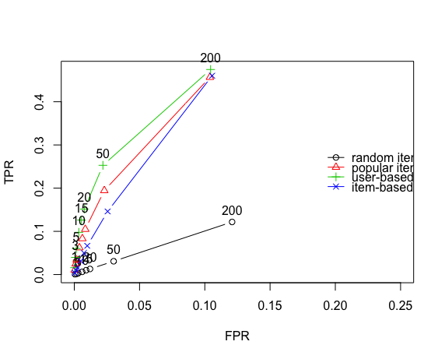

**Figure 1.3.1** ROC curves of the four methods.

On the other hand, the running time of the IBCF lasts more than 50 times than the other methods last. With the performance in the ROC figure, we can conclude that the IBCF may not be the best choice within these four methods.

**4.2 Hybrid Collaborative Filtering Algorithm**

1. For old users

We used an exhaustive search approach to find the best weights, $α$, $β$, in Formula (1) so that we can have the minimum MAE for rating predictions. Because calculating MAE for all users can be overwhelming on a single machine, we randomly sampled a user, the one with user ID 917, and produced the following table:

**Table 4.2.1 MAE Values with Different $α$** , $β$

|  |  |  |  |  |  |  |  |  |
| --- | --- | --- | --- | --- | --- | --- | --- | --- |
| MAE | $α$ =0.1 | $α$ =0.2 | $α$ =0.3 | $α$ =0.4 | $α$ =0.5 | $α$ =0.6 | $α$ =0.7 | $α$ =0.8 |
| $β$ =0.1 | 0.942 | 0.972 | 0.987 | 0.995 | 0.990 | 0.997 | 0.997 | 1.008 |
| $β$ =0.2 | 0.942 | 0.976 | 0.984 | 0.982 | 0.981 | 0.986 | 0.993 | - |
| $β$ =0.3 | 0.938 | 0.962 | 0.971 | 0.970 | 0.975 | 0.980 | - | - |
| $β$ =0.4 | 0.933 | 0.965 | 0.965 | 0.974 | 0.978 | - | - | - |
| $β$ =0.5 | 0.935 | 0.971 | 0.976 | 0.979 | - | - | - | - |
| $β$ =0.6 | 0.944 | 0.970 | 0.978 | - | - | - | - | - |
| $β$ =0.7 | 0.965 | 0.969 | - | - | - | - | - | - |
| $β$ =0.8 | 0.971 | - | - | - | - | - | - | - |

In order to find out the minimum MAE in Table 4.2.1, we computed the relative minimal values of MAE for each column and plot Figure 4.2.1 as belows:

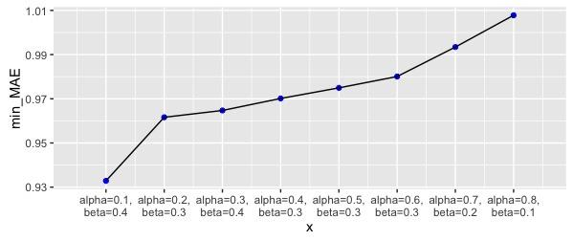

**Figure 4.2.1** Line Segment Graph for Age Group Classification

When $α=0.1，β=0.4$，MAE has the minimal value, that is, the algorithm is most accurate.

Thus, we used $α=0.1，β=0.4$ to calculate the overall similarity for every two old users using Formula (1) and predicted ratings using Formula (3). The evaluation of this method is discussed in Section 4.3.

1. For new users

As we mentioned previously, it is important to create an information database, that is, lookup tables for demographic characteristics and preferences for movie genres based on old users. For example, we listed top 5 genres for males and females respectively in Table 4.2.2.

**Table 4.2.2 Lookup Table for Gender and Preference for movie genres**

|  |  |  |  |  |  |
| --- | --- | --- | --- | --- | --- |
| Gender | Preference1 | Preference2 | Preference3 | Preference4 | Preference5 |
| F | Drama | Comedy | Romance | Thriller | Adventure |
| M | Drama | Comedy | Action | Thriller | Romance |

Thus, according to Table 4.2.2, we see drama and comedy are popular among both females and males. And men prefer action movies while women like romantic ones.

As for the age, we divided the life of people into 11 groups as in the Figure 4.2.2, based on the way United Union classifies age in relation to the minimum ages for enrollment in different education levels.

Lookup tables for age group and preference for movie genres, as well as occupation and preference for movie genres, are given in Appendix Table 1 and Table 2. Some patterns are found as well: 1) children are not likely to insist on watching movies for a long time and following the story clues of drama; instead they love drama more; 2) teenagers are fond of thriller and adventure movies because young people can bear exciting or shocking things; 3) romantic movies are popular among grown-ups; 4) compared to other occupations, the movie genres that lawyers prefer are thriller, action, war.

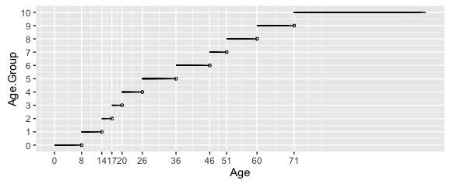

**Figure 4.2.2** Line Segment Graph for Age Group Classification

For we did not have new users in reality, we randomly sampled 3 users to be the new users and removed their ratings but kept their demographic features as in Table 4.2.3.

**Table 4.2.3 Table for New Users’ Characteristics**

|  |  |  |  |  |  |  |  |  |
| --- | --- | --- | --- | --- | --- | --- | --- | --- |
| user_id | age | gender | occupation | Preference1 | Preference2 | Preference3 | Preference4 | Preference5 |
| 75 | 24 | M | entertainment |  |  |  |  |  |
| 519 | 22 | M | other |  |  |  |  |  |
| 611 | 46 | M | librarian |  |  |  |  |  |

For every new user, we found out the intersection set of preference for different demographic characteristics from the lookup tables. We filled in the blanks in Table 4.2.3 and produced the Table 4.2.4.

**Table 4.2.4 Table for New Users’ Characteristics**

|  |  |  |  |  |  |  |  |  |
| --- | --- | --- | --- | --- | --- | --- | --- | --- |
| user_id | age | gender | occupation | Preference1 | Preference2 | Preference3 | Preference4 | Preference5 |
| 75 | 24 | M | entertainment | Drama | Comedy | Romance | Action | Adventure |
| 519 | 22 | M | other | Drama | Comedy | Romance | Action | Adventure |
| 611 | 46 | M | librarian | Drama | Comedy | Romance | Thriller | Sci-Fi |

Then, using Formula (4) and (5), we calculated similarities between new users and any old users and recommended according to the rating predictions.

**4.3 Comparison between Algorithms**

We used MAE as a criterion to evaluate our algorithm.

1. For old users

We randomly sampled 3 users to do predictions considering large amount of time if predicting for all users. We compared our results with the results we got using UBCF algorithm from Recommenderlab package.

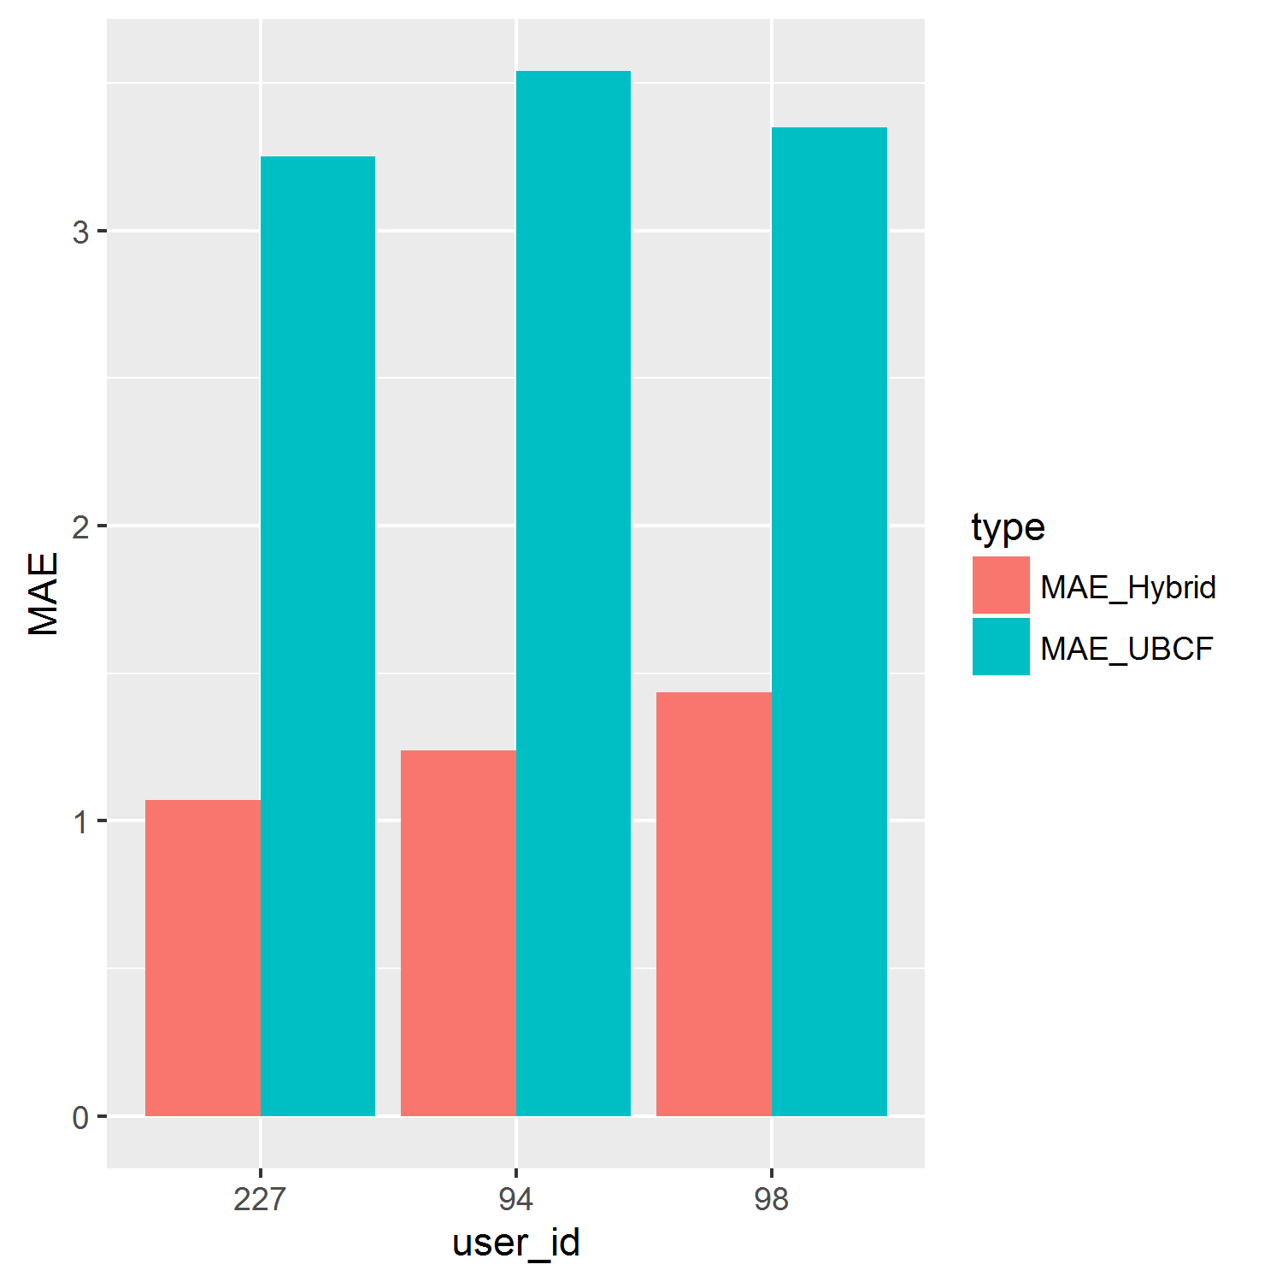

**Figure 4.3.1 Predicting MAE for Old Users**

From the Figure 4.3.1, we can see that for all of the 3 users, MAEs using the hybrid collaborative filtering algorithm are much smaller than those using traditional user-based collaborative filtering algorithm. Therefore, we can say that adding users’ demographic characteristics and preferences helps us improve the prediction accuracy.

1. For new users

We continued to utilize the 3 random samples in Section 4.2.2) to be new users. Since the traditional collaborative filtering algorithms cannot handle the cold start problem, we cannot use MAE to evaluate the results of recommended movies. However, in practice, we just removed the actual ratings for these users. We could thus compare the recommendations with the movies that the corresponding user had watched in reality. In this way, we believe that the recommended movies could fit the taste for that user to some extent.

We took user with user ID 611 as an example. Top 10 recommended movies were listed in Table 4.3.1 in the order of decreasing rating predictions.

**Table 4.3.1 Top 10 Movie Recommendations for User 611**

|  |  |  |  |
| --- | --- | --- | --- |
| Order | Movie_tittle | Order | Movie_tittle |
| 1 | Contact (1997) | 6 | Leaving Las Vegas (1995) |
| 2 | English Patient, The (1996) | 7 | Pulp Fiction (1994) |
| 3 | Fargo (1996) | 8 | Return of the Jedi (1983) |
| 4 | Godfather, The (1972) | 9 | Star Wars (1977) |
| 5 | L.A. Confidential (1997) | 10 | Titanic (1997) |

Among these 10 movies, 3 of them, *Titanic (1997)*, *English Patient, The (1996)*, and *L.A. Confidential (1997)* were watched by user 611 in the past. In addition, *English Patient, The (1996)* and *L.A. Confidential (1997)* got the true rating of 5 by him or her; while *Titanic (1997)* had the true rating of 3, which was reasonable because it was the last recommendation in our case. Similar results happened for the other two samples. For there are a large number of alternative movies and some movies are potential preference for the user but have not been watched, the results can show the effectiveness of hybrid recommender system for new users.

**5 Sending Work to High-Throughput Computing**

Moving on from the 100k dataset to the 20m dataset, we are faced with significant challenges. Firstly, it’s the total scale augmentation. While dealing with the 100k dataset, no matter which collaborative algorithm we use, we needed to perform a lot of matrix computation. This would no longer become possible when facing the computation of a single giant matrix. We need to slice the matrix into the needed pieces for a selected user and make sure the specific single piece would give us a good prediction accuracy. Secondly, we no longer have the demographic information, which means the other methods we proposed in the previous parts are no longer applicable. In reality, those methods would be a great supplement of our existing collaborative algorithms. However, with missing values or not requiring certain information when registering, being able to utilize the rating matrix becomes our fundamental issue in scaling up and create a recommender system that deals with big data.

**5.1 Setting Up HT Condor Workspace**

Using CHTC severs to perform high-throughput computing involves the following steps:

Step 1: Creating account and installing R with the packages we need;

Note that by installing related packages, we have compiled a rather large single installed R software. We sent our R software and our 500MB raw rating data to SQUID, a web proxy from which pre-staged input files and executables can be downloaded into jobs using CHTC's proxy HTTP address.

Step 2: Submitting computation code along with the compiled R software;

We use the adapted code we use when sending an affinity matrix to the Recommenderlab. Before sending the matrix, we wrote code to clean up the data into a giant rating matrix with row names being user ID and column names being movie title, just like the MovieLense data prebuilt in the Recommenderlab package. (Code can be find on Github.) Note that we still need a great algorithm to pick related users and items for the selected user to create such matrices.

Step 3: Replicating Step 2 for more slices and combining the results with better recommending accuracy.

**5.2 Creating Related Matrices**

We propose the following ways to create related matrices. Note due to the limited time, we did not have enough time to test every one of them. The real world solutions differ and complicate with the pursuit of accuracy.

Firstly, we could use the **random selection** of items from the affinity matrix. With the involvement of all items the selected user rated, we already have part of our columns. Then we randomly selected the same amount of movies the user didn’t rate before. With such truncation, we ranked the total rated numbers every user has marked and pick the top ones.

Secondly, as an improvement of the random selection of items, we chose only related items. The “related” here is defined as with **similar genres**. We cleaned the item table first to separate the genre lists. Then we used the same genre preferences from the user’s rated items to select the same proportions of movies. We only chose the most popular ones to include. The user selection was the same as the first one.

One limitation of the two possible methods is that we cannot make sure how many extra items and users we are going to select to improve the overall prediction accuracy. This overall prediction accuracy need to be further explored. The other limitation is the customization of the taste. The inclusion of only popular movies in the genre can be disastrous facing a user who likes independent movies. In this case, we need to search the other users based on the similar rated movies.

The third method we propose is based on the selected items of the selected users. For each genre, we sorted within the selected movies and found a good coverage of the number of those movies from other users’ ratings to create a subset of users. And we further selected the most rated items within those users.

This method would become more reliable compared with the previous two. To make users feel that the movies suggested actually satisfy their tastes, a combination of more possible methods are needed. But note we still don’t have a possible solution for the cold start problem since we do not have demographical information any more. In this case, we will only suggest trended or all-time popular items based on the geographical information of the users or the timestamps of the ratings.

**6 Other Methods**

So far, we have already talked about the Collaborative Filtering Algorithm using Recommenderlab and the Hybrid Collaborative Filtering Algorithm. By using Matrix Factorization and Slope-One Algorithm, we can build different recommender systems. Given more time, we can utilize existing APIs from the Internet and put it on CHTC to test and compare.

**7 Conclusion**

In this study, we have compared algorithms in R package Recommenderlab which only consider users’ ratings with another hybrid recommender system that also combines the information of users’ demographic characteristics and preferences for movie genres. According to the previous work, hybrid collaborative filtering algorithm improves the prediction accuracy and thus the rationality of recommendations based on the MAE criterion. What is more, hybrid collaborative filtering algorithm can solve the cold start challenge which is impossible using traditional collaborative filtering algorithm. Therefore, the hybrid recommender system is better than recommender system using collaborative filtering algorithms from Recommenderlab package.

However, there exists something that can be further explored or improved if we had a lot more time:

1) As we can see in Section 4.3, hybrid collaborative filtering algorithm outperformed user-based collaborative filtering algorithm. However, when we tried to find the best weights, $α$, $β$ (see Section 4.2), it took us about an hour to do the calculation. This is on the basis of the fact that we just set 8 different values for either $α$ or $β$, which yielded only a very small amounts of choices, 36 combinations, considering the possible values for $α$, $β$. It’s better to find a more efficient way to calculate.

2) In our hybrid algorithm, we manually picked 60 nearest neighbors to do predictions. However, the number of nearest neighbors may also affect the prediction accuracy. We can further explore the effect of choosing different numbers of nearest neighbors and determine the most appropriate number of nearest neighbors to predict ratings.

3) In terms of CHTC work, we did not have enough time to learn and apply our algorithms on the final 20m dataset. We only tested and run it on a selected dataset. Also, we still need to figure out possible ways to create overlaps and bridging mechanisms of the overlaps in order to give final recommendations. Because computing power in a single machine is so limited that we randomly sampled and tuned our parameters or evaluated the predictions among different algorithms based on samples. Taking advantage of high throughput computing, we can make our results more robust.

**Reference**

[1] Mean absolute error. (n.d.). In *Wikipedia*. Retrieved from <https://en.wikipedia.org/wiki/Mean_absolute_error>.

[2] Jeff M. Phillips. (2013). *Jaccard Similarity and Shingling*. Retrieved from <https://www.cs.utah.edu/~jeffp/teaching/cs5955/L4-Jaccard+Shingle.pdf>.

[3] Department of International Economic and Social Affairs. (1982). Provisional Guidelines on Standard International Age Classifications. *Statistics Papers, M*(74). Retrieved from <http://unstats.un.org/unsd/publication/SeriesM/SeriesM_74e.pdf>.

[4] Suresh K. Gorakala, Michele Usuelli. (2015). *Building a Recommender System with R*.

[5] Michael Hahler, (). *recommenderlab: A Framework for Developing and Testing Recommendation Algorithms.* Retrieved from <https://cran.r-project.org/web/packages/recommenderlab/vignettes/recommenderlab.pdf>.

**Appendix**

**Table 1 Lookup Table for Age Group and Preference for movie genres**

|  |  |  |  |  |  |
| --- | --- | --- | --- | --- | --- |
| Age_Group | Preference1 | Preference2 | Preference3 | Preference4 | Preference5 |
| 0 | Comedy | Romance | Drama | Action | Thriller |
| 1 | Drama | Thriller | Comedy | Sci-Fi | Action |
| 2 | Drama | Thriller | Romance | Adventure | War |
| 3 | Drama | Comedy | Action | Thriller | Romance |
| 4 | Drama | Comedy | Romance | Action | Adventure |
| 5 | Drama | Comedy | Action | Thriller | Romance |
| 6 | Drama | Comedy | Action | Thriller | Romance |
| 7 | Drama | Comedy | Romance | Thriller | Sci-Fi |
| 8 | Drama | Comedy | Thriller | Romance | Sci-Fi |
| 9 | Drama | Comedy | Action | Thriller | Romance |
| 10 | Drama | Thriller | Romance | Action | Crime |

**Table 2 Lookup Table for Occupation and Preference for movie genres**

|  |  |  |  |  |  |
| --- | --- | --- | --- | --- | --- |
| Occupation | Preference1 | Preference2 | Preference3 | Preference4 | Preference5 |
| administrator | Drama | Comedy | Action | Thriller | Sci-Fi |
| artist | Drama | Action | Thriller | Adventure | Romance |
| doctor | Drama | Thriller | Romance | Comedy | Crime |
| educator | Drama | Comedy | Romance | Thriller | Sci-Fi |
| engineer | Drama | Comedy | Action | Thriller | Romance |
| entertainment | Drama | Comedy | Action | Romance | Sci-Fi |
| executive | Drama | Comedy | Romance | Thriller | Sci-Fi |
| healthcare | Drama | Comedy | Action | Thriller | Sci-Fi |
| homemaker | Drama | Comedy | Action | Thriller | Adventure |
| lawyer | Drama | Thriller | Action | War | Sci-Fi |
| librarian | Drama | Comedy | Thriller | Romance | Sci-Fi |
| marketing | Drama | Comedy | Thriller | Romance | Sci-Fi |
| none | Drama | Thriller | Romance | Action | Adventure |
| other | Drama | Comedy | Action | Romance | Sci-Fi |
| programmer | Drama | Comedy | Romance | Thriller | Adventure |
| retired | Drama | Comedy | Thriller | Romance | Adventure |
| salesman | Drama | Comedy | Action | Thriller | Romance |
| scientist | Drama | Action | Romance | Thriller | Adventure |
| student | Drama | Comedy | Action | Thriller | Romance |
| technician | Drama | Comedy | Action | Thriller | Romance |
| writer | Drama | Comedy | Action | Romance | Adventure |